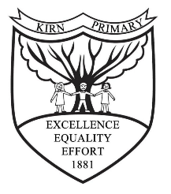
November Newsletter

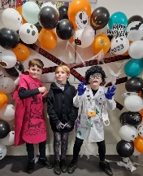
October Halloween Disco
PTA used pupil voice feedback to create a Halloween Disco that was an event to remember. Children enjoyed a chocolate tombola, spooky lucky dip, a DJ and much more! We are incredibly thankful to the PTA and parent helpers for putting together this event. If you would like to be part of the PTA or help at the next event please let the office know and they can add you to our mailing list.
Assemblies
‘Kirn is a Learning community that works positively together to achieve great things’
As part of our vision we have been inviting in members of the community to come in and speak with the children about the important roles they play in our community.
Our spotlight – UNCRC
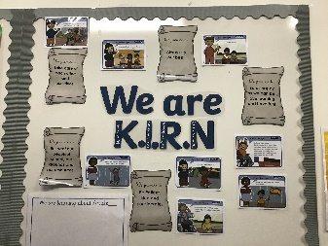
Take a look at our class charters. Each class has created a class charter that shows a commitment from pupils and staff to ensure that everyone feels happy, safe and secure to learn and that the United Nations Charter for the Rights of the Child is the starting point for every child. You can find all our class charters on our website. www.kirn.argyll-bute.sch.uk
Community
Kirn Café at the Kirk
Laura Mitchell will be hosting a weekly café at Kirn Kirk for all members of the community to enjoy. There will be coffee, cake and chat with visiting experts from the school and community. Keep your eye on our Facebook page for updates.
Family Singing group
Every Monday evening 6pm-7pm pupils and their family members can come and enjoy singing together. This is an informal group who love to sing and have fun together.
Parents evening
Parents Evening will be on 22nd and 23rd of November during which you can discuss your child’s progress through the flyer with the class teacher. Appointments will be sent out in due course.
December
November | Fri 17th Children in need Dress down day  Tues 21st Parents Evening 3:15-5:15pm  Wed 22nd Parents Evening 4pm-6pm  Mon 27th In-Service Day
December | Mon 4th Love in a box collection  Wed 6th Thurs 7th Poppy Bud Bus (P4-P7)  Mon 11th Visiting Theatre company performance Cinderella Panto  Tues 12th P1 and P2 Nativity 9:30am  Wed 13th Christmas Concert 2pm and 6pm  Thurs 14th Christmas lunch served in school ( no alternative served on this day)  Fri 15th P1 P2 party  Mon 18th P3 P4 party  Tues 19th P5 P6 party  Wed 20th P7 party  Wed 20th Church Service 10am All Welcome  Thurs 21st School closes 2:30pm
January | Thurs 4th School Opens

